**Case Study: ONLINE BANKING ANALYSIS - PySpark**

**By Afreen Sultana A**

**Loading the 3 csv files**

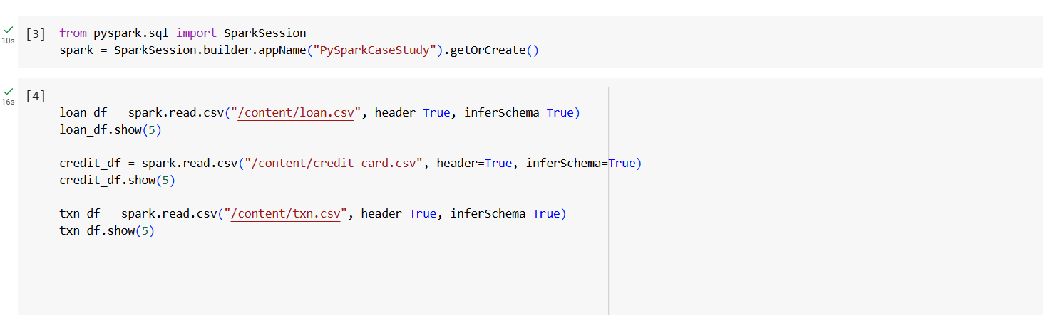

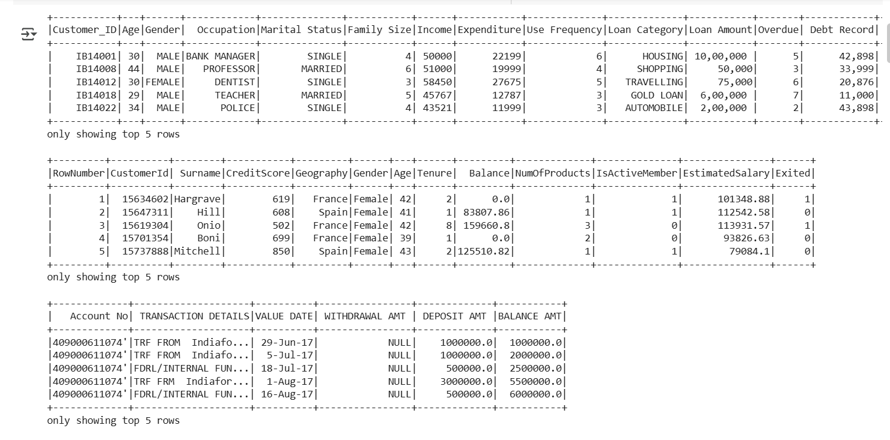

1. **From Loan CSV file**
2. number of loans in each category

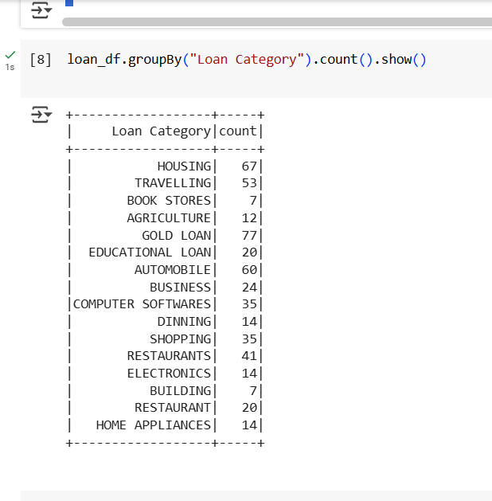

1. number of people who have taken more than 1 lack loan

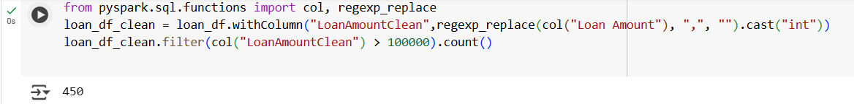

1. number of people with income greater than 60000 rupees

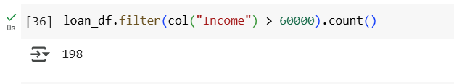

1. number of people with 2 or more returned cheques and income less than 50000

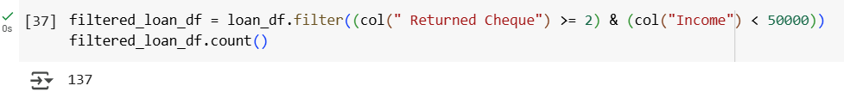

1. number of people with 2 or more returned cheques and are single

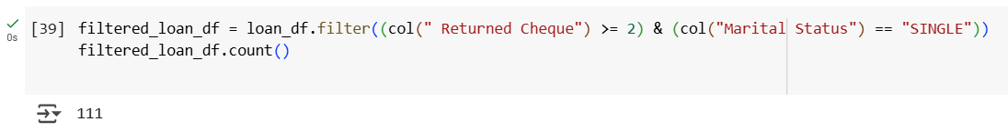

1. number of people with expenditure over 50000 a month

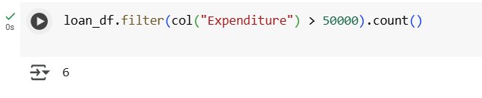

1. number of members who are eligible for credit card

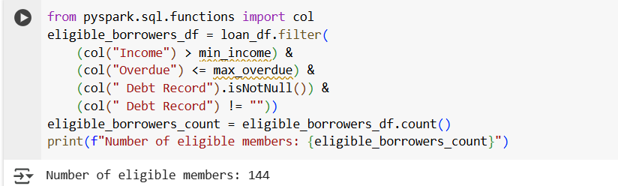

1. **From Credit.csv file**
2. credit card users in Spain

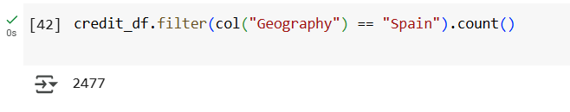

1. number of members who are eligible and active in the bank

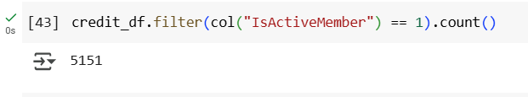

1. **From Transaction file**
2. Maximum withdrawal amount in transactions and MINIMUM WITHDRAWAL AMOUNT OF AN ACCOUNT in txn.csv

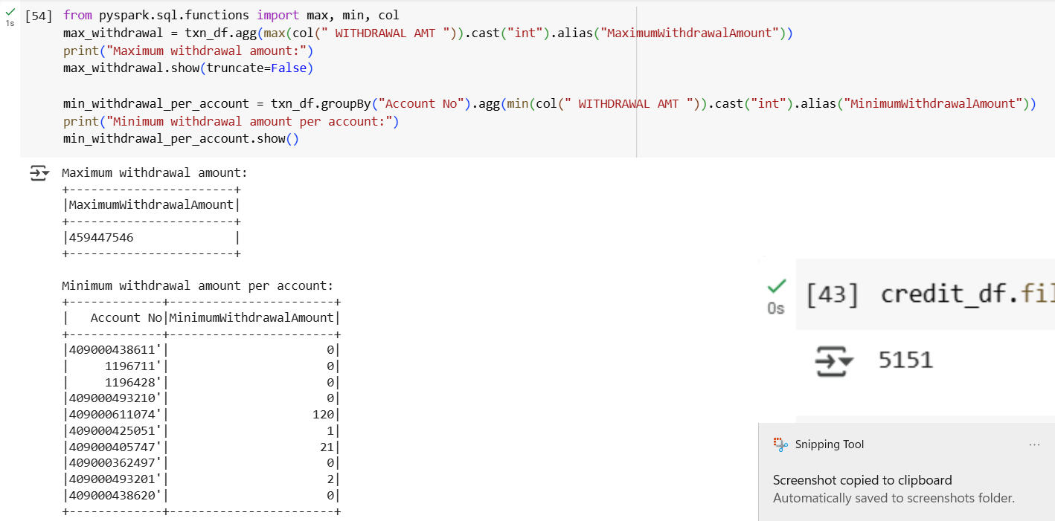



1. MAXIMUM DEPOSIT AMOUNT OF AN ACCOUNT



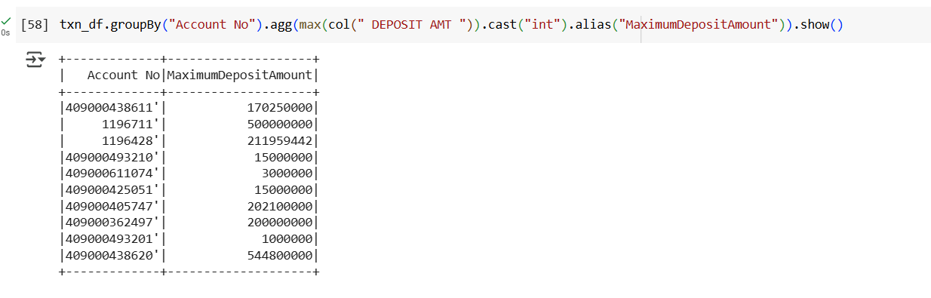

1. MINIMUM DEPOSIT AMOUNT OF AN ACCOUNT

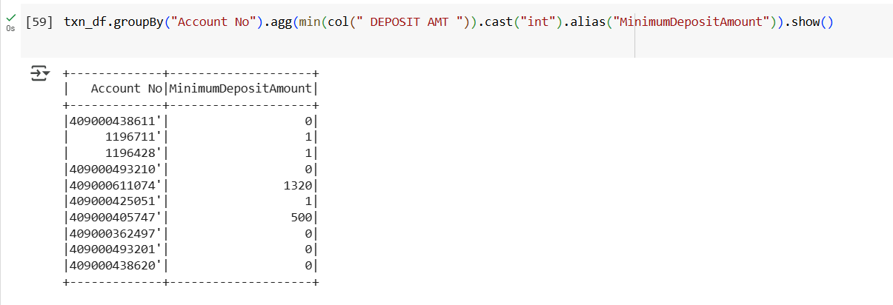

1. Sum of balance in every bank account

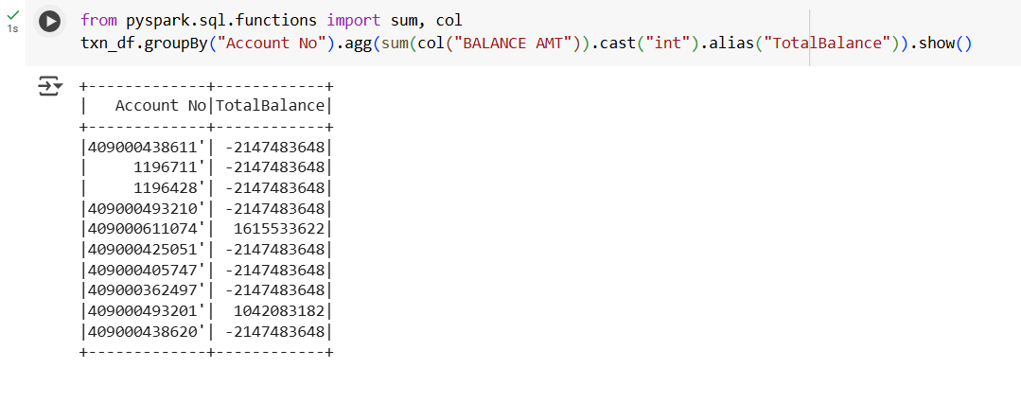

1. Number of transaction on each date

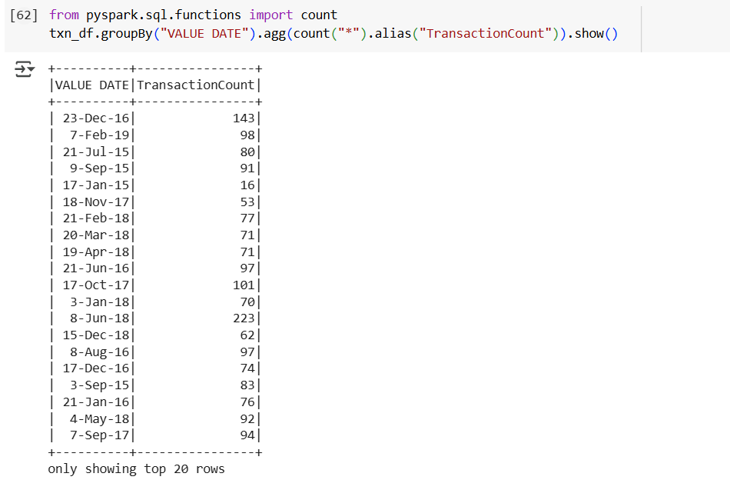

1. List of customers with withdrawal amount more than 1 lakh